**DAILY ONLINE ACTIVITIES SUMMARY**

|  |  |  |  |  |  |  |  |  |
| --- | --- | --- | --- | --- | --- | --- | --- | --- |
| **Date:** | **30/06/2020** | | | | | **Name:** | **Pratibha Shetti** | |
| **Sem & Sec** | **IV sem & B section** | | | | | **USN:** | **4AL18CS062** | |
| **Online Test Summary** | | | | | | | | |
| **Subject** | | **-** | | | | | | |
| **Max. Marks** | | **30** | | **Score** | | | **-** | |
| **Certification Course Summary** | | | | | | | | |
| **Course** | **Blockchain Basics** | | | | | | | |
| **Certificate Provider** | | | **Greatlearning academy** | | **Duration** | | | **2.5hours** |
| **Coding Challenges** | | | | | | | | |
| **Problem Statement1:** Write a C++ Program to Move all zeroes to end of array using Two-Pointers.  **Problem Statement2:** Write a C Program to generate first n Ugly Numbers.  **Problem Statement3:**  Write a C Program to check whether the number is Ugly or not. | | | | | | | | |
| **Status: Executed** | | | | | | | | |
| **Uploaded the report in Github** | | | | | **YES** | | | |
| **If yes Repository name** | | | | | <https://github.com/pratibhashetty-123/Lockdown-coding-for-C> | | | |
| **Uploaded the report in slack** | | | | | **YES** | | | |

Online Test Summary: No internals conducted today.

Online Certification Course Summary: In today’s session I have about the Industry Challenges for the Blockchain Adoption there are many challenges for industries while dealing with blockchain technology like scalability, energy consumption etc.

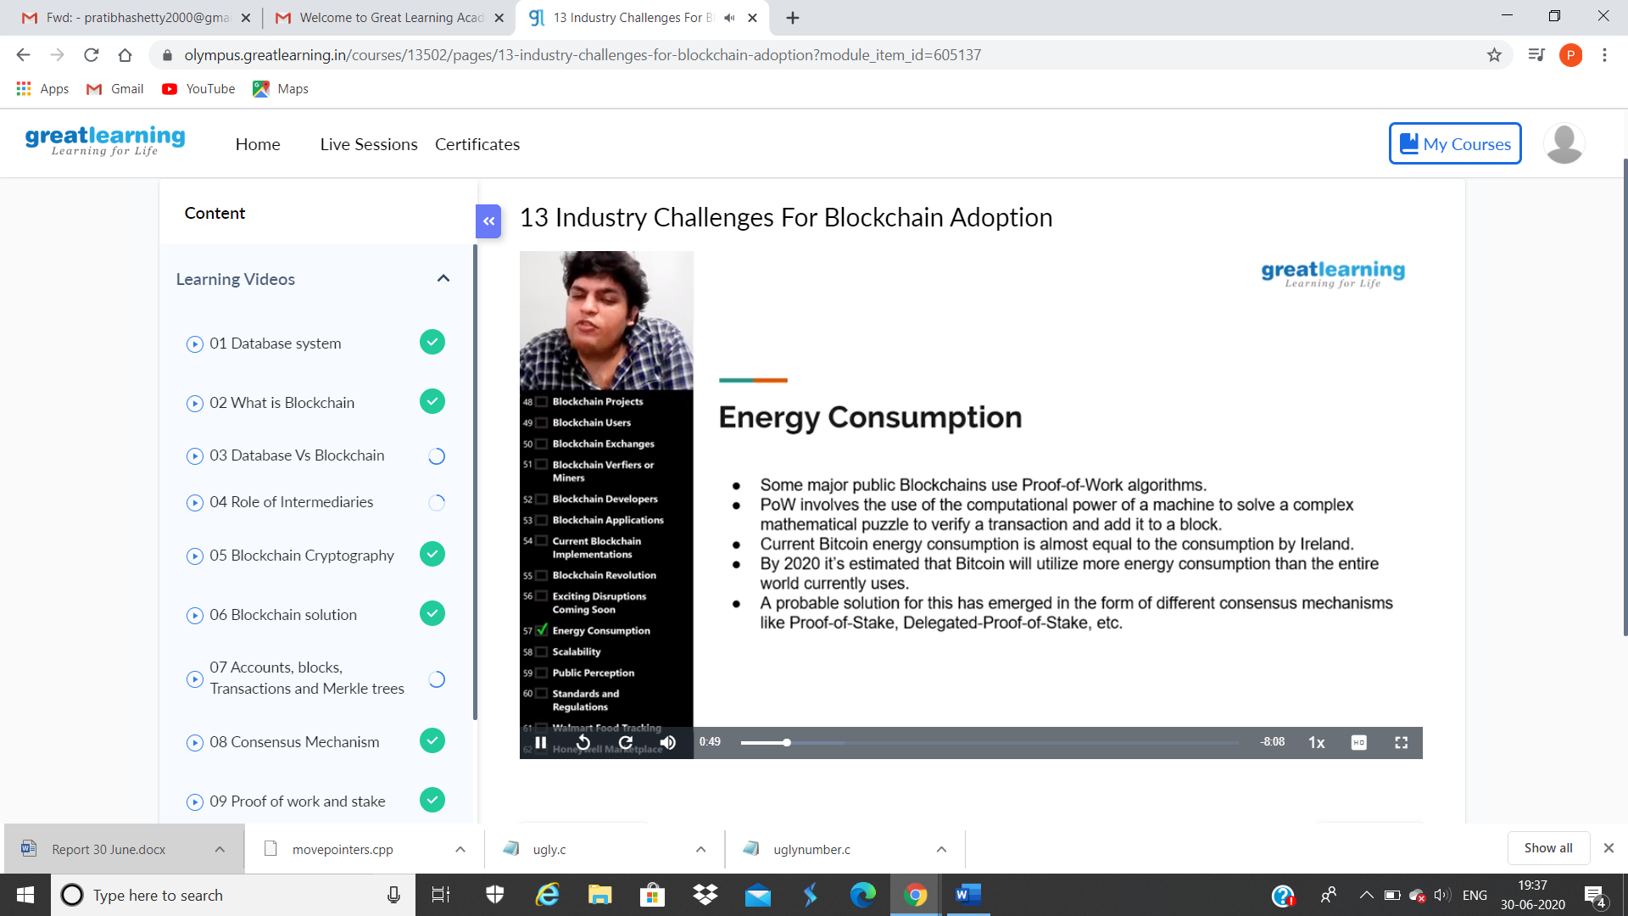

This is the snapshot of today’s session.

Online Coding Summary: **Today I had received programs from prof. Shilpa CSE Dept. and Prof. Venkatesh CSE Dept. The programs are mentioned above in the coding challenges(pg.01). I have also uploaded them to my Github repository.**

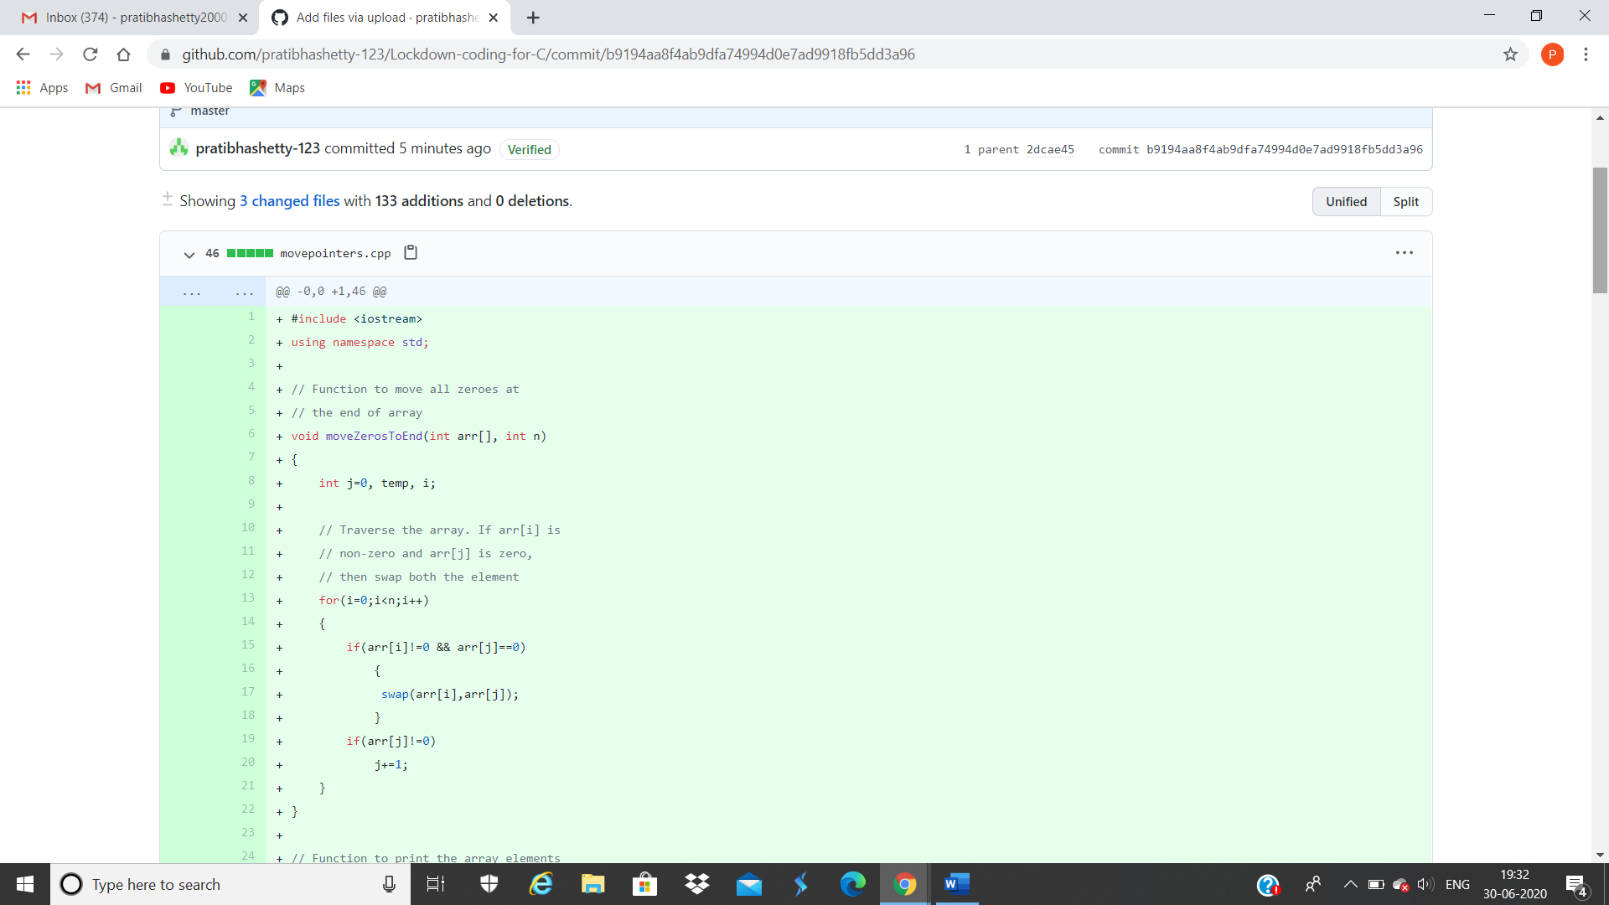

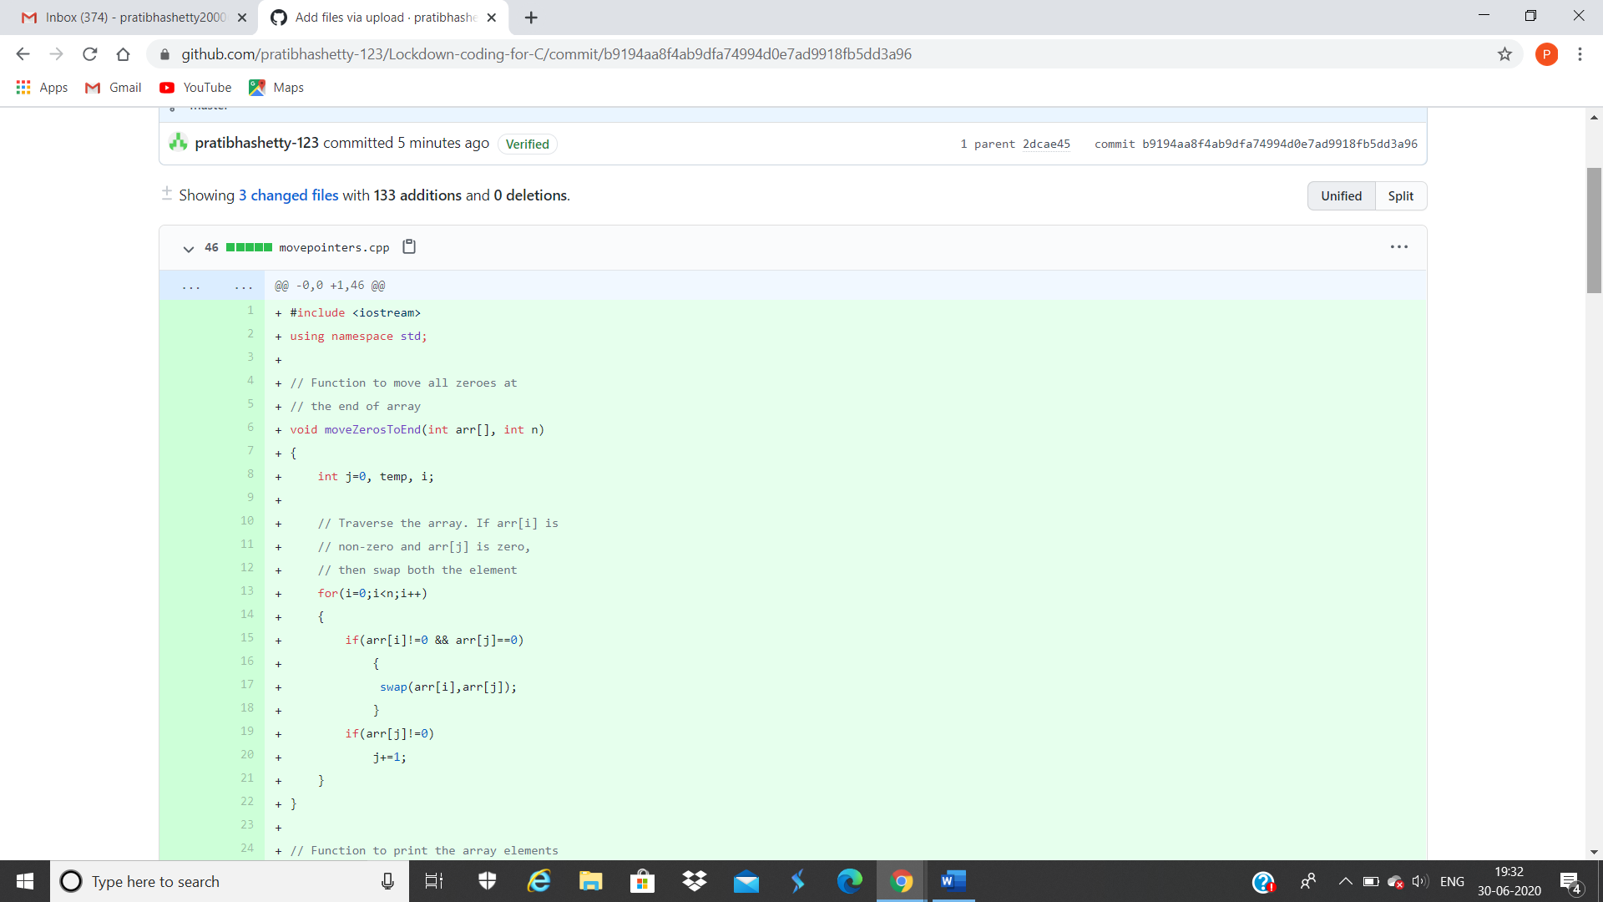

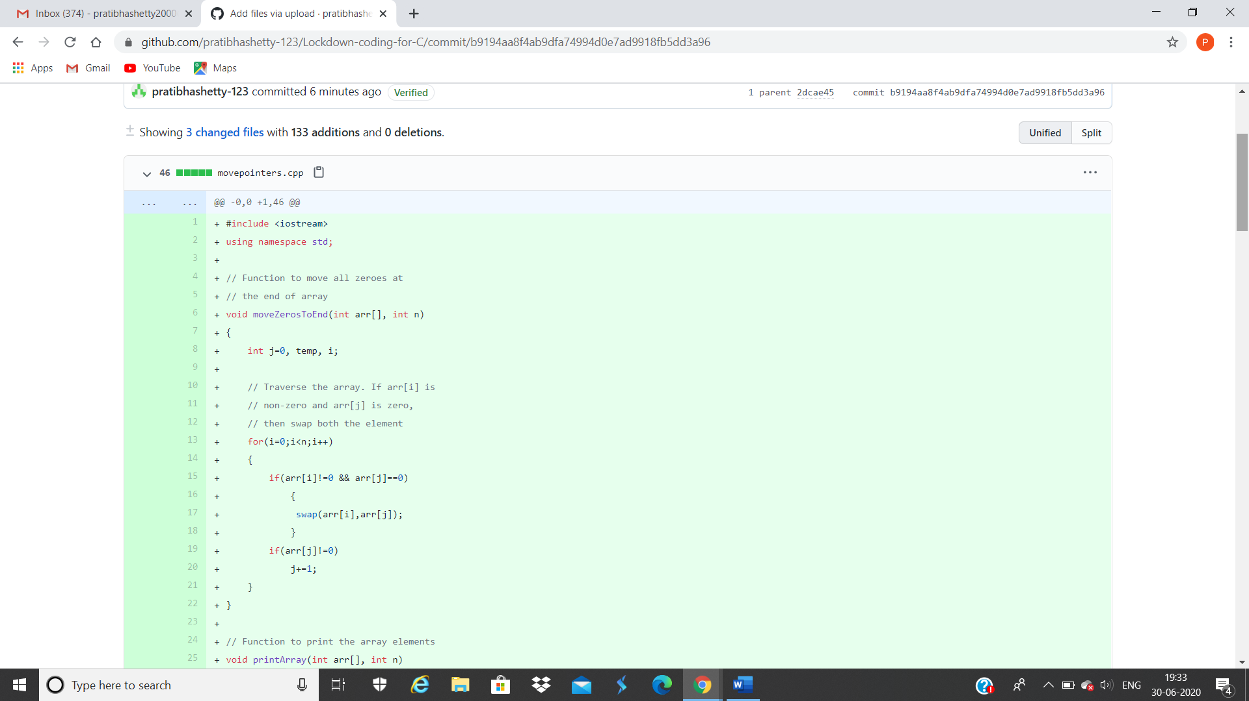

**This is the snap shot of my Github repository** were I have uploaded the code. File name is movepointers.cpp, ugly.c and uglynumbers.c

Online Training: Today I had attended the online training organized by CSE Department AIET. The training was on C++ programming language done by Prof. Shruthi Shetty J. CSE Dept. After the session the quiz was conducted.